Postal Dice Forge Tables
Last Turn Table
Sub-turn | P1 Gets | P2 Gets | P3 Gets | P4 Gets | Active Player | Reinforcements | Temple / Islands | Second Action
1 | r1,r2 | r1,r2 | r1,r2 | r1,r2 | Player 1 | Elder/Owl/Hind | Sanctuary or Island | pay 2 sun
2 | r1,r2 | r1,r2 | r1,r2 | r1,r2 | Player 2 | Elder/Owl/Hind | Sanctuary or Island | pay 2 sun
3 | r1,r2 | r1,r2 | r1,r2 | r1,r2 | Player 3 | Elder/Owl/Hind | Sanctuary or Island | pay 2 sun
4 | r1,r2 | r1,r2 | r1,r2 | r1,r2 | Player 4 | Elder/Owl/Hind | Sanctuary or Island | pay 2 sun
5 | r1,r2 | r1,r2 | r1,r2 | r1,r2 | Player 1 | Elder/Owl/Hind | Sanctuary or Island | pay 2 sun
Player's Dice
 | Die 1 |  |  |  | Die 2
 | Player 1 | Player 2 | Player 3 | Player 4 | Player 1 | Player 2 | Player 3 | Player 4
Face 1 | 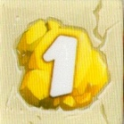 |  |  |  | 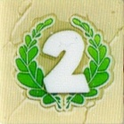
Face 2 | 
Face 3
Face 4
Face 5 |  |  |  |  | 
Face 6
Player Details
 |  | Resources |  |  |  | Tokens
Player | Location | Gold | Sun | Moon | Glory | X2 | Triton | Cards
Player One | Start | 3/12 | 0/6 | 0/6 | 0 | 0 | 0
Player Two | Start | 2/12 | 0/6 | 0/6 | 0 | 0 | 0
Player Three | Start | 1/12 | 0/6 | 0/6 | 0 | 0 | 0
Player Four | Start | 0/12 | 0/6 | 0/6 | 0 | 0 | 0

THE TEMPLE
The Sanctuary
Cost | 2 Gold | 2 Gold | 3 Gold | 3 Gold | 4 Gold | 5 Gold | 6 Gold | 8 Gold | 12 Gold
Option 1 | 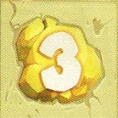 |  | 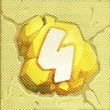 |  | 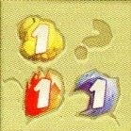 | 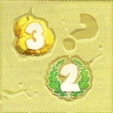 | 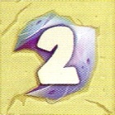 | 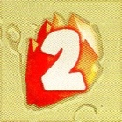 | 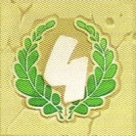
Option 2 |  |  |  |  | 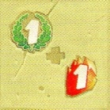 |  |  |  | 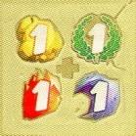
Option 3 |  |  |  |  | 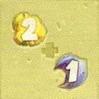 |  |  |  | 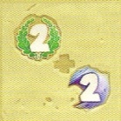
Option 4 |  |  |  |  | 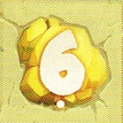 |  |  |  | 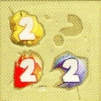
The Gardens
Pool | Option 1 | Option 2 | Option 3 | Option 4
Mirror of the Abyss | 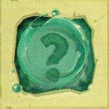
Guardian's Shield | 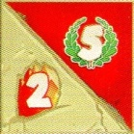 | 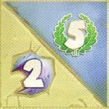 | 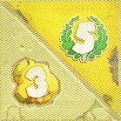 | 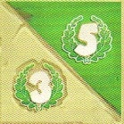
Celestial Ship | 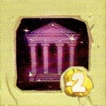
Tenacious Boar | 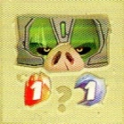 | 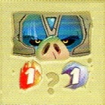 | 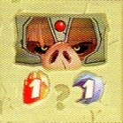 | 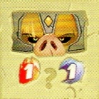
Helm of Invisibility | 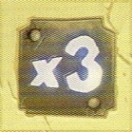

Heroic Feats
Position | Cost | Card | No. Remaining | Glory | Effect
Sun 1 | 1 Sun | The Elder | 4 | 0 | Each round, on your turn, may spend 3 gold for 4 glory
 | 1 Sun | Wild Spirits | 4 | 2 | Gain 3 gold and 3 moon
Sun 2 | 2 Sun | Guardians Owl | 4 | 4 | Each round, on your turn, gain one sun, moon, or gold
 | 3 Sun | Minotaur | 4 | 8 | Opponents roll die and lose any resources rolled (cannot go below zero)
Sun 3 | 4 Sun | Gorgon | 4 | 14 | No effect
 | 5 Sun | Mirror of the Abyss | 4 | 10 | Forge a mirror face onto one of your die. When rolled, choose effect from an opponent’s die face
Moon 1 | 1 Moon | Blacksmiths Hammer | 4 | 0 | Take hammer card. May spend gold to fill card (15 spaces) to score 10 glory (2 sides)
 | 1 Moon | Blacksmiths Chest | 4 | 2 | Expand inventory limit to 16 gold, 9 sun and 9 moon
Moon 2 | 2 Moon | Silver Hind | 4 | 2 | Each round, on your turn, roll one die an extra time
 | 3 Moon | Tenacious Boar | 4 | 6 | Opponent forges a boar face to one of their die. if rolled, you gain either 1 sun, 1 moon or 3 glory
Moon 3 | 4 Moon | Ferryman | 4 | 12 | No effect
 | 5 Moon | Helmet of Invisibility | 4 | 3 | Forge a 3x face to one of your die. If rolled, this multiplies the effect of your other die by 3
Centre | 6 Sun | Sphinx | 4 | 10 | Roll one die four times and receive all the effects
 | 6 Moon | Cancer | 4 | 8 | Roll both die twice and receive all the effects
 | 5 Sun + 5 Moon | Hydra | 4 | 26 | No effect
End of Round
Sub-turn | P1 Roll | P2 Roll | P3 Roll | P4 Roll | Active Player | Reinforcements | Temple / Islands | Second action
1 | x,y | x,y | x,y | x,y | Player 2 | Elder/Owl/Hind | Sanctuary or Island | pay 2 sun
2 | x,y | x,y | x,y | x,y | Player 3 | Elder/Owl/Hind | Sanctuary or Island | pay 2 sun
3 | x,y | x,y | x,y | x,y | Player 4 | Elder/Owl/Hind | Sanctuary or Island | pay 2 sun
4 | x,y | x,y | x,y | x,y | Player 1 | Elder/Owl/Hind | Sanctuary or Island | pay 2 sun
5 | x,y | x,y | x,y | x,y | Player 2 | Elder/Owl/Hind | Sanctuary or Island | pay 2 sun

